109062318簡弘哲

1. Producer1 running & semaphore changes

According to .map file, the address of _Producer1 is 0014, so I set a breakpoint there. Red block corresponds to the variable initialization ch=’A’, and blue block is the assembly code of SemaphoreWaitBody and decrease Semaphore ‘empty’ (addr = 22H) by 1

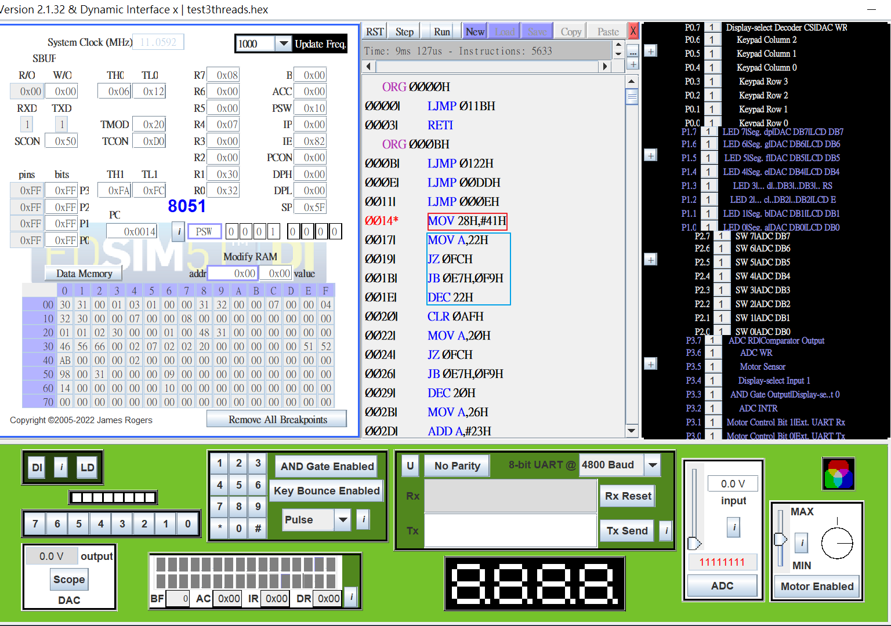

1. Producer2 running & semaphore changes

According to .map file, the address of _Producer2 is 0057, so I set a breakpoint there. Red block corresponds to the variable initialization num=’0’, and blue block is the assembly code of SemaphoreWaitBody and decrease Semaphore ‘empty’ (addr = 22H) by 1

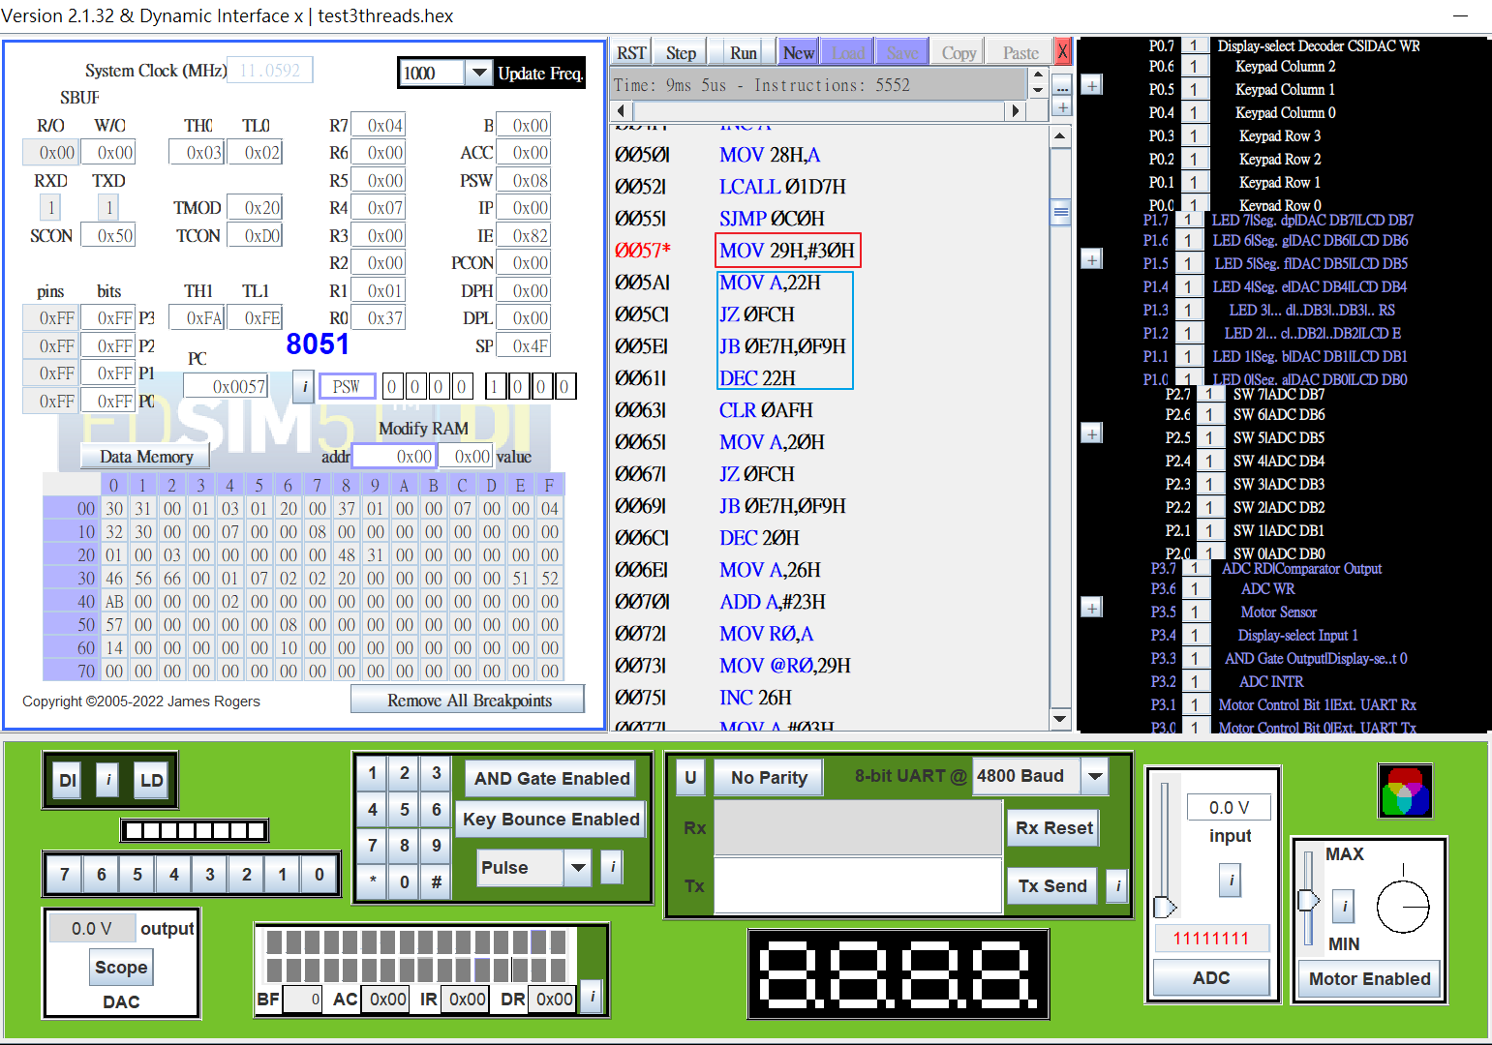

1. Consumer running & semaphore changes

According to .map file, the address of _Consumer is 009A, so I set a breakpoint there. Red block corresponds to the initialization of TMOD, TH1…, and blue block is the assembly code of SemaphoreWaitBody and decrease Semaphore ‘full’(addr = 21H) by 1

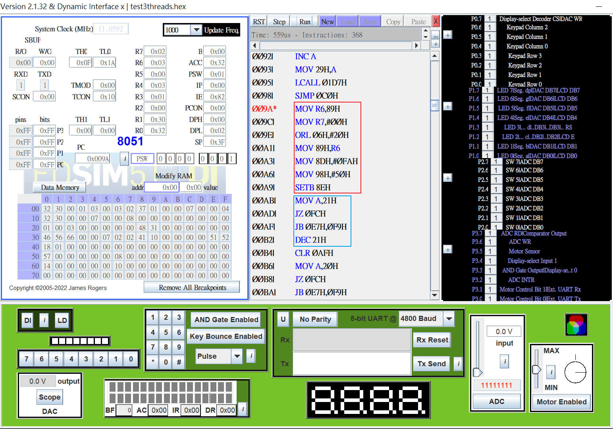

1. Before: Unfair version

If Producer1 is spawned before Producer2, then UART would only output characters(as shown below)

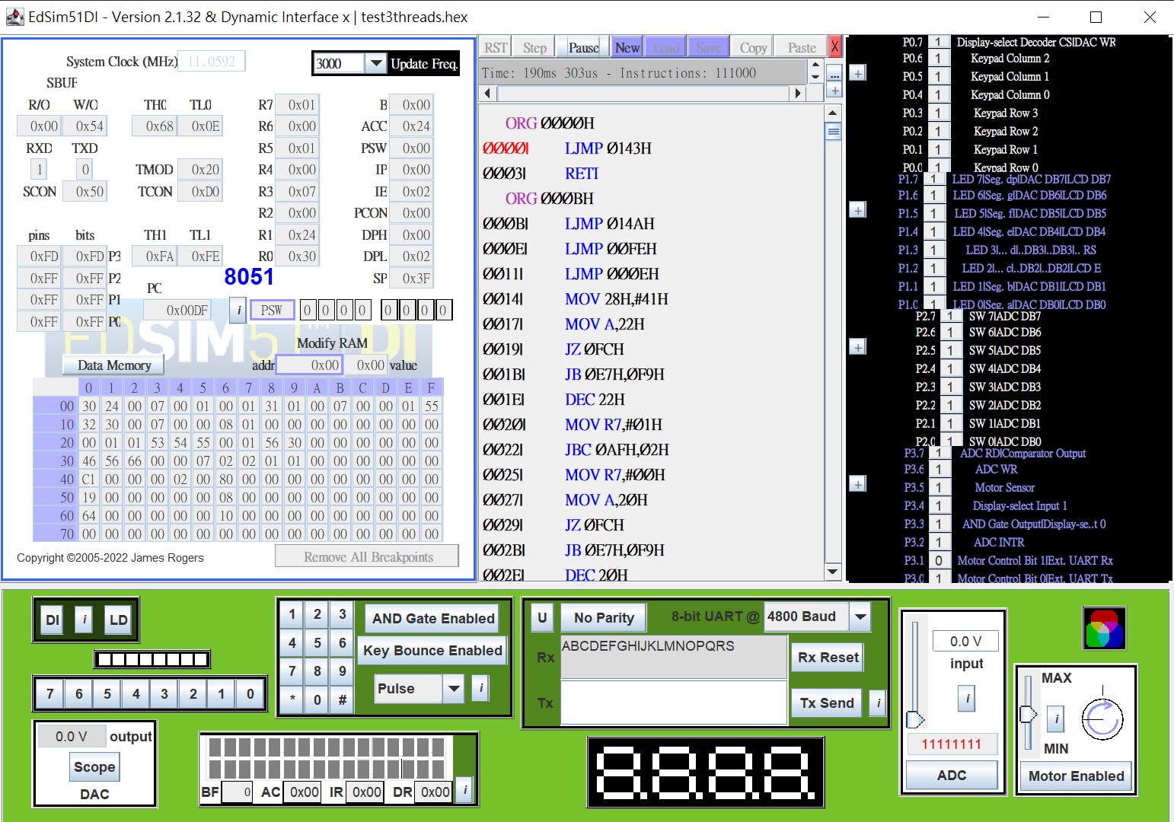

If Producer2 is spawned before Producer1, then UART would only output numbers(as shown below)

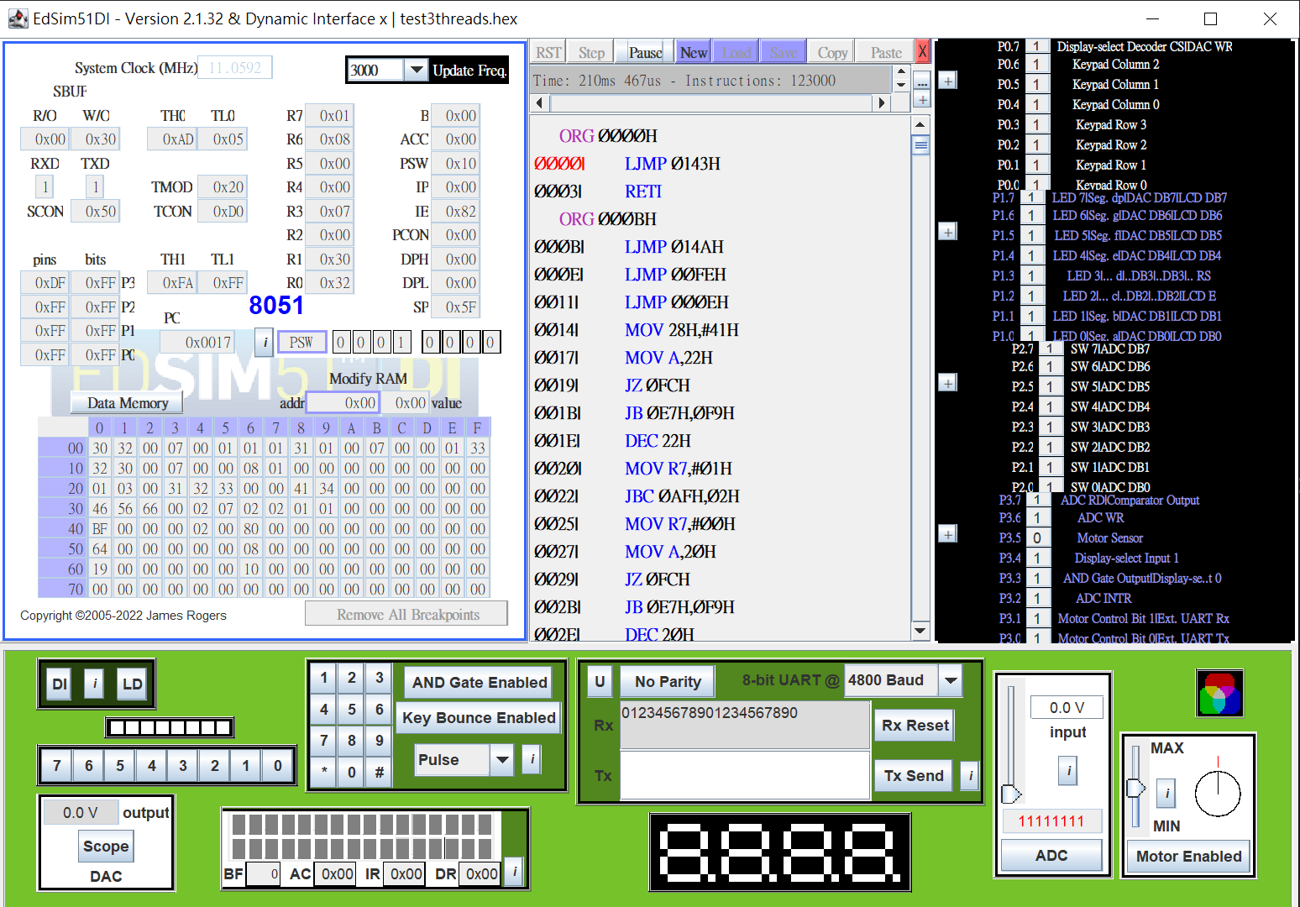

1. After: fair version & Fairness

I add an explicit ThreadYield() at the end of Producer1 and 2 to force real round-robin, so that after each producer went through 1 iteration, it will switch to the other thread by calling ThreadYield() explicitly. The screenshot below take Producer1 as example(Producer2 the same).

If Producer1 is spawned first in main, then the first character of UART output will be alphabet a, then number 0, b, 1,…etc(as shown below)

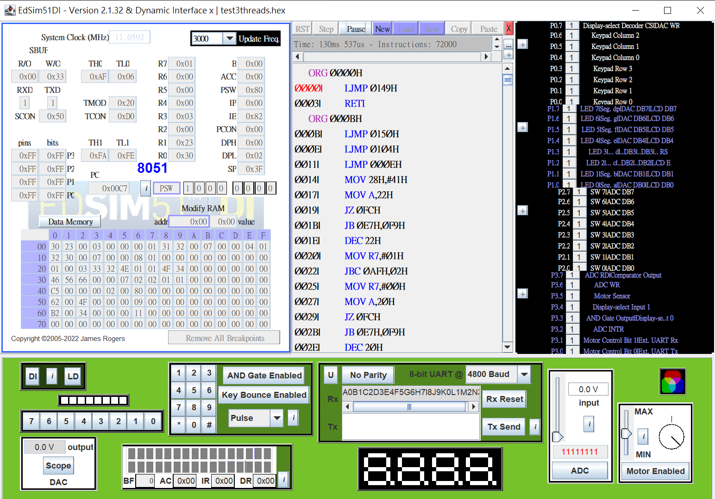

If Producer2 is spawned first in main, then the first character of UART output will be number 0, then alphabet a, 1, b,…etc(as shown below)

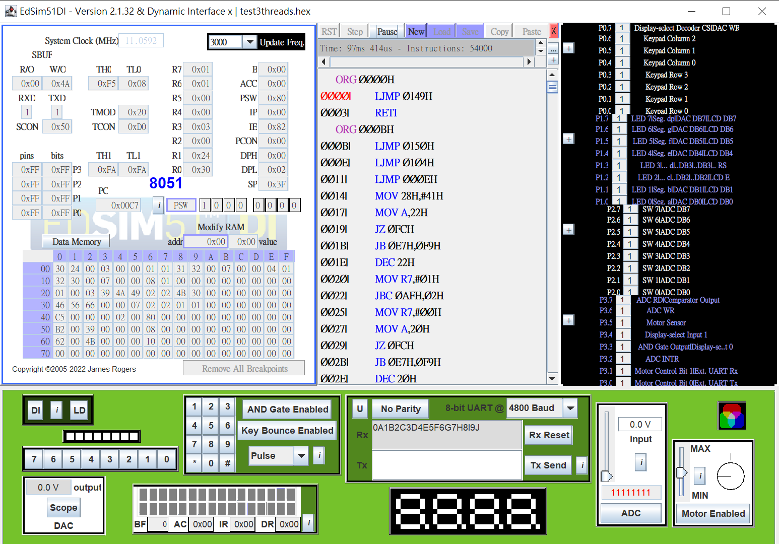

1. Typescript and screenshots

